**DBMS LAB CYCLE 3**

**QUESTION SET-3**

Create the following tables.

* Primary key, SSN of EMPLOYEE should be created as a sequence starting at 1.
* There should be at least 8 employees and 5 departments
* Check salary range of employees is between 30,000 and 75,000 using check predicate.

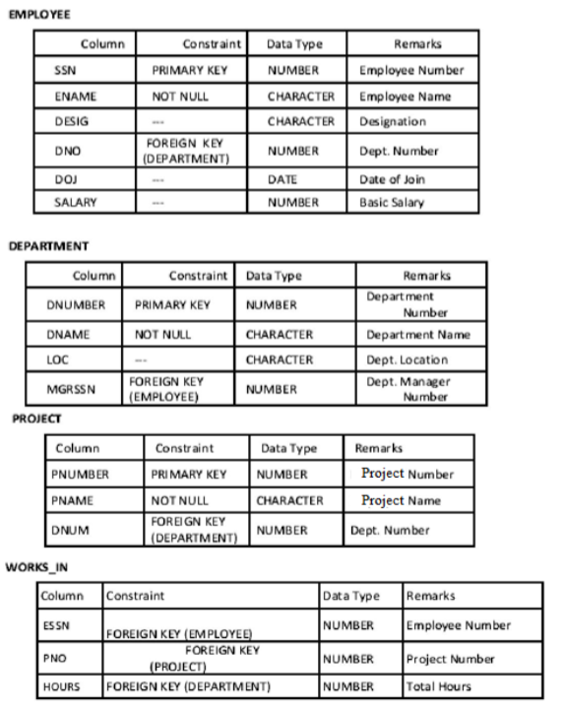

**QUERY**

**Create table EMPLOYEE**

CREATE TABLE EMPLOYEE

(

SSN INT NOT NULL AUTO_INCREMENT,

ENAME VARCHAR(40) NOT NULL,

DESIGN VARCHAR(20),

DNO INT,

DOJ DATE,

SALARY INT,PRIMARY KEY (SSN),

CHECK(SALARY BETWEEN 30000 AND 75000)

);

DESCRIBE EMPLOYEE;

**OUTPUT**



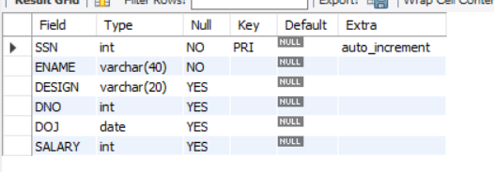

**QUERY**

**Create table DEPARTMENT**

CREATE TABLE DEPARTMENT

(DNUMBER INT,

DNAME VARCHAR(20),

LOC VARCHAR(40),

MGRSSN INT REFERENCES EMPLOYEE(SSN),

PRIMARY KEY(DNUMBER)

);

DESCRIBE DEPARTMENT;

**OUTPUT**



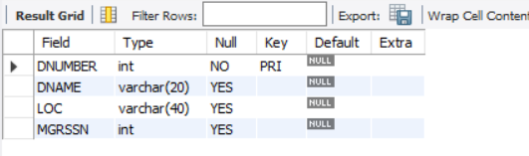

**QUERY**

**Create table PROJECT**

CREATE TABLE PROJECT

(

PNUMBER INT,

PNAME VARCHAR(15),

DNUM INT,

FOREIGN KEY(DNUM) REFERENCES DEPARTMENT(DNUMBER),

PRIMARY KEY(PNUMBER)

);

DESCRIBE PROJECT;

**OUTPUT**



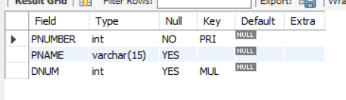

**QUERY**

**Create table WORK_IN**

CREATE TABLE WORK_IN

(

ESSN INT,

PNO INT,

HOURS INT,

FOREIGN KEY (ESSN)

REFERENCES EMPLOYEE(SSN),

FOREIGN KEY (PNO) REFERENCES PROJECT(PNUMBER),

FOREIGN KEY (HOURS) REFERENCES DEPARTMENT(DNUMBER)

);

DESCRIBE WORK_IN;

**OUTPUT**



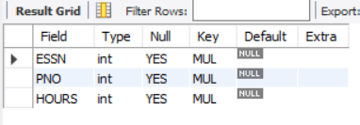

**QUERY**

**Insert into EMPLOYEE**

INSERT INTO EMPLOYEE(ENAME,DESIGN,DNO,DOJ,SALARY)VALUES('Abhi','HR',2,'2009-04-12',70000 ),

('bhama','admin',1,'2008-03-10',75000 ),('chriz','sales',3,'2015-06-23',35000 ),

('diya','production',5,'2015-07-21',32000 ),('govind','production',5,'2015-09-12',35000 ),

('hima','finance',4,'2013-01-19',51000 ),('ira','hr',2,'2010-03-15',45000 ),

('sandeep','finance',4,'2010-07-26',49000 );

SELECT * FROM EMPLOYEE;

**OUTPUT**



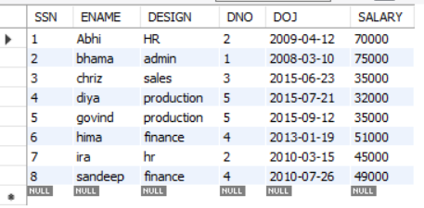

**QUERY**

INSERT INTO DEPARTMENT(DNUMBER,DNAME,LOC)VALUES(1,'Admin','Chennai'),(2,'HR','Banglore'),(3,'Sales','Kochi'),(4,'Finance','Delhi'),(5,'Production','Trivandrum');

SELECT * FROM DEPARTMENT;

**OUTPUT**



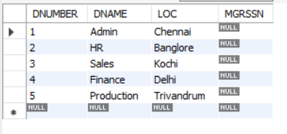

**QUERY**

INSERT INTO PROJECT(PNUMBER,PNAME,DNUM)VALUES(11,'Bancs',3),(12,'Nielesan',5),(13,'WorldBank',1),(14,'Airlines',2),(15,'Amex',4);

SELECT * FROM PROJECT;

**OUTPUT**



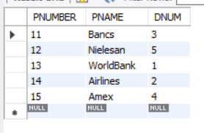

**QUERY**

INSERT INTO WORK_IN(ESSN,PNO,HOURS)VALUES(1,14,NULL),(4,13,NULL),(8,12,NULL),(6,15,NULL),(2,11,NULL),(3,13,NULL);

SELECT * FROM WORK_IN;

**OUTPUT**



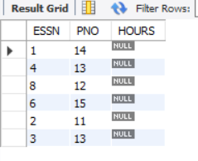

**QUERY**

**Update table Department**

UPDATE DEPARTMENT SET MGRSSN=2 WHERE DNUMBER=1;

UPDATE DEPARTMENT SET MGRSSN=1 WHERE DNUMBER=2;

UPDATE DEPARTMENT SET MGRSSN=3 WHERE DNUMBER=3;

UPDATE DEPARTMENT SET MGRSSN=6 WHERE DNUMBER=4;

UPDATE DEPARTMENT SET MGRSSN=7 WHERE DNUMBER=2;

UPDATE DEPARTMENT SET MGRSSN=4 WHERE DNUMBER=5;

UPDATE DEPARTMENT SET MGRSSN=5 WHERE DNUMBER=5;

**OUTPUT**

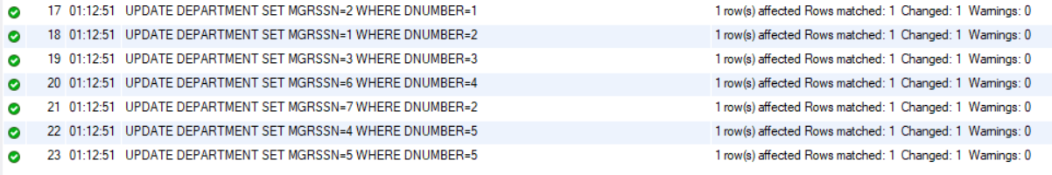

**1.** Retrieve all employees in department 5 whose salary is between Rs 30,000 and Rs 40,000.

**QUERY**

SELECT e.ENAME FROM EMPLOYEE e LEFT OUTER JOIN DEPARTMENT d on d.DNUMBER=e.DNO WHERE e.SALARY BETWEEN 30000 AND 40000 AND d.DNUMBER=5;

**OUTPUT**

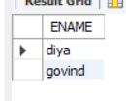

**2.** Retrieve a list of employees and the projects they are working on, where the departments and the employees within the department are alphabetically by name.

**QUERY**

SELECT e.ENAME,d.DNAME FROM EMPLOYEE e LEFT OUTER JOIN DEPARTMENT d on e.DNO=d.DNUMBER ORDER BY d.DNAME ASC,e.ENAME ASC;

**OUTPUT**

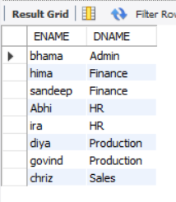

**3.** Retrieve the project number, the project name, and the number of employees who work in each project.

**QUERY**

SELECT p.PNUMBER,p.PNAME,count(e.SSN) FROM WORK_IN w LEFT OUTER JOIN PROJECT p on w.PNO=p.PNUMBER LEFT OUTER JOIN EMPLOYEE e on w.ESSN=e.SSN GROUP BY p.PNAME,p.PNUMBER;

**OUTPUT**

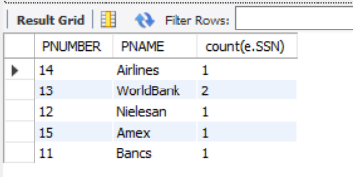

**4. F**or the project on which more than two employees work, retrieve the project number, the project name, and the number of employees who work on the project.

**QUERY**

SELECT p.PNUMBER,p.PNAME,count(e.SSN) FROM WORK_IN w LEFT OUTER JOIN PROJECT p on w.PNO=p.PNUMBER LEFT OUTER JOIN EMPLOYEE e on w.ESSN=e.SSN GROUP BY p.PNAME,p.PNUMBER HAVING count(e.SSN) > 2;

**OUTPUT**

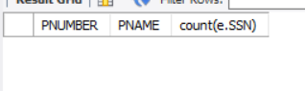



**5.** For each project, retrieve the project number, the project name, and the number of employees from department 5 who work on the project.

**QUERY**

SELECT p.PNUMBER,p.PNAME,d.DNUMBER,count(e.ssn) FROM PROJECT p LEFT OUTER JOIN DEPARTMENT d on d.DNUMBER=p.DNUM LEFT OUTER JOIN EMPLOYEE e on e.DNO=p.DNUM GROUP BY p.PNAME,p.PNUMBER,d.DNUMBER HAVING d.DNUMBER=5;

**OUTPUT**

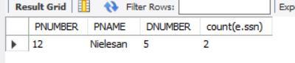

**6.** For the departments having more than five employees, display the department id and the number and details of employees earning more than Rs 40,000 per month.

**QUERY**

SELECT d.dname,d.dnumber,e.ssn,e.ename,e.design,e.doj,e.salary FROM department d, employee e WHERE (SELECT COUNT(*) FROM employee e WHERE e.dno = d.dnumber AND e.salary>40000)>4 AND e.dno=d.dnumber GROUP BY d.dname,d.dnumber,e.ssn,e.ename,e.design,e.doj,e.salary;

**OUTPUT**

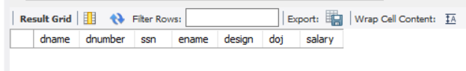



**7.** Create a synonym for the VIEW created on natural join of emp and dept tables.

**QUERY**

create VIEW EMP_DEPT_VIEW as select * from EMPLOYEE NATURAL JOIN department;

CREATE SYNONYM EMP_DEPTS FOR EMP_DEPT_VIEW;

SELECT * FROM EMP_DEPT;

**OUTPUT**



**8.** Use the tables Employee, and Department. Perform the operations as mentioned below:

a.)Display the employee details, departments that the departments are same in both the emp and dept. (Equi-join)

**QUERY**

SELECT * From EMPLOYEE e,DEPARTMENT d WHERE e.DNO=d.DNUMBER;

**OUTPUT**

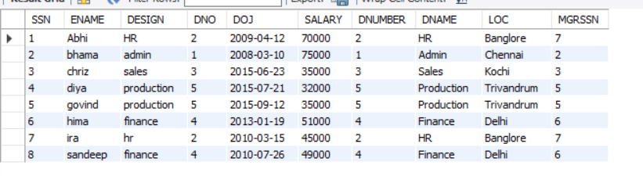

b.) Display the employee details, departments that the departments are

not same in both the emp and dept. (Non Equi-join)

**QUERY**

SELECT * FROM EMPLOYEE e,DEPARTMENT d WHERE NOT(e.DNO=d.DNUMBER);

**OUTPUT**

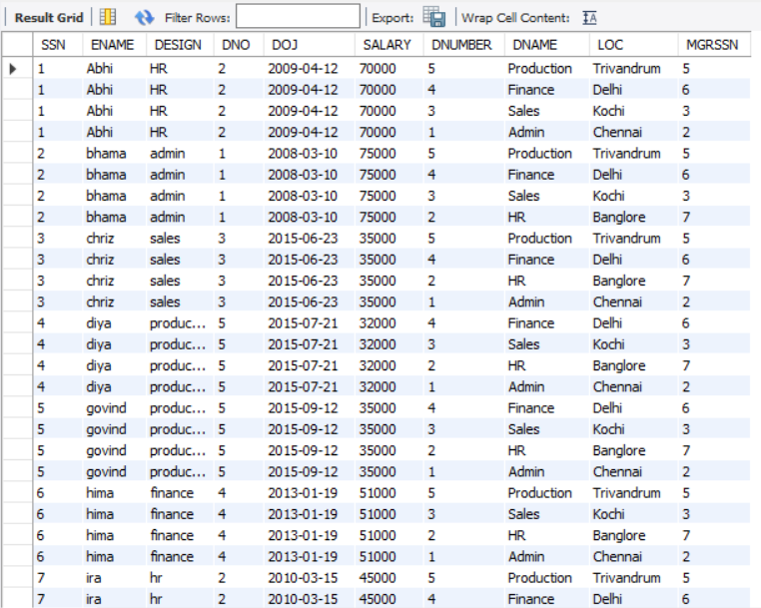

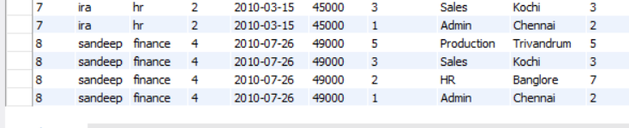

c.) Perform Left outer join on the emp and dept tables.

**QUERY**

SELECT * FROM EMPLOYEE e LEFT OUTER JOIN DEPARTMENT d ON e.DNO=d.DNUMBER;

**OUTPUT**

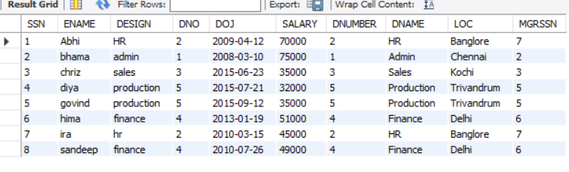

d.) Perform Right outer join on the emp and dept tables.

**QUERY**

SELECT * FROM EMPLOYEE e RIGHT OUTER JOIN DEPARTMENT d ON e.DNO=d.DNUMBER;

**OUTPUT**

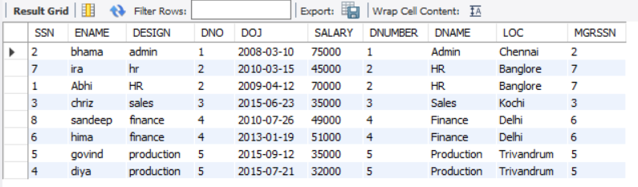

e.) Perform inner join on the emp and dept tables.

**QUERY**

SELECT * FROM EMPLOYEE e INNER JOIN DEPARTMENT d ON e.DNO=d.DNUMBER;

**OUTPUT**

